About you | [Salutation] | Rachel | [Middle name] | Stauffer
About you | [Enter your biography]
About you | University of Virginia

Your article
Zamyatin, Evgeny
[Enter any variant forms of your headword – OPTIONAL]
Russian author most famous for his dystopic novel We [My], Zamyatin was highly influential as an author, journal editor, leader of literary organisations, and as an instructor and researcher in naval engineering.
Russian author most famous for his dystopic novel We [My], said to have influenced George Orwell’s 1984. Criminalised in the pre-Revolutionary period by the tsarist regime for his revolutionary tendencies and denounced post-Revolution as a traitor to the ideals of Russian Communism, Zamyatin was highly influential as an author, journal editor, leader of literary organisations, and as an instructor and researcher in naval engineering. In 1931, with Stalin’s permission, Zamyatin moved to France, where he died of a heart attack in 1937. His contributions to Russian and Soviet literature were newly acknowledged in the 1980s when his reputation as a traitor was renounced.

Evgeny Zamyatin was born in the Russian countryside to a middle-class family and attended St. Petersburg Polytechnic Institute as a student of naval engineering. Travel for this work combined with the revolutionary climate of St. Petersburg significantly influenced Zamyatin’s writing. Frequent participation in St. Petersburg’s revolutionary activity leading to the 1905 revolution resulted in Zamyatin’s arrest and exile, which also served as themes in his literary works. Although officially Zamyatin had been expelled from St. Petersburg, he remained there as a resident from 1906 until 1911 teaching in the naval engineering program of St. Petersburg Polytechnic Institute. He was ejected from St. Petersburg by authorities in 1911. While exiled outside of the city, Zamyatin wrote A Provincial Tale [Uezdnoe], which was well received by critics. Permitted to return to St. Petersburg in 1913, Zamyatin continued his work at the Polytechnic Institute, engaging with the literary community, publishing his own stories and novels, and also producing Russian translations of English works, including those of H.G. Wells, George Bernard Shaw, and Jack London. He also edited for prominent journals and provided leadership in literary organizations, significantly impacting young authors, including an important group of emerging young authors known as the Serapion Brotherhood, an organization formed in 1921, devoted to communion among authors and dedication to craft rather than ideological content.

In the post-Revolutionary period, Zamyatin was considered to be a Fellow Traveler, the term used to refer to writers who were mostly in agreement with the goals of the revolution, but who did not always subscribe to the objectives of Communism. Under Lenin and Trotsky’s leadership, the Fellow Travelers were safe. Indeed, during this period in 1920-21, Zamyatin wrote his most well known works, the novel We, and the short stories “Cave” [Peshchera] and “Mamai” [Mamai]. We is an anti-utopian novel that describes life in a post-apocalyptic, futuristic, collective society in which humans have numbers instead of names, love and imagination are criminalised, and daily life in the nation of One State is meticulously scheduled and highly restrictive. Citizens live unquestioningly devoted to the leader, the nation, and a perceived sense of safety from the rest of the world. Influences for this novel may include Zamyatin’s acquaintance with H.G. Wells, or as Elizabeth Stenbock-Fermor has asserted, Jerome K. Jerome’s “The New Utopia”.

An outspoken opponent to the party line after Lenin’s death in 1924 and Stalin’s consolidation of power in 1928, Zamyatin was denounced as a traitor and stripped of his authority in literary organizations in 1929. For two years he endured relentless criticism and isolation in the Soviet Union, finally appealing personally to Stalin in 1931 for permission to leave Russia. In 1931, his request was granted and he lived the rest of his life in France. In the 1980s, We and other works by Zamyatin were officially published in the USSR, and his reputation as an important literary figure was reinstated.

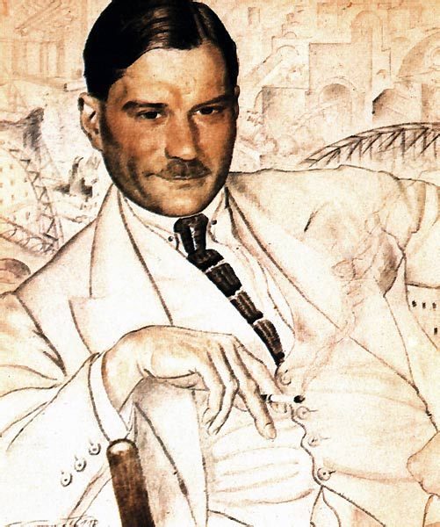

Further reading:
Brown, Edward J. Brave New World, 1984, and We. Ann Arbor: Ardis, 1976. Focuses on Zamyatin’s text with consideration of Huxley and Orwell.

-------. Russian Literature Since the Revolution. Cambridge: Harvard University Press, 1963. Addresses many other authors, but discusses Zamyatin in the context of the Serapion Brotherhood, the Fellow Travelers, and the post-Revolutionary period.

Richards, David J. Zamyatin: A Soviet Heretic. New York: Hillary House, 1962.
Contains an extensive biography and significant descriptions and analysis of Zamyatin’s works.

Russell, Robert. Zamyatin’s We. London: Bristol, 2000.
An update of older sources with new perspectives on We. Excellent bibliography.

Shane, Alex M. “Zamyatin”. In Handbook of Russian Literature. Ed. Victor Terras. New Haven: Yale University Press, 1985. Provides an outstanding overview of Zamyatin’s life and works with cross-references within the Handbook.

